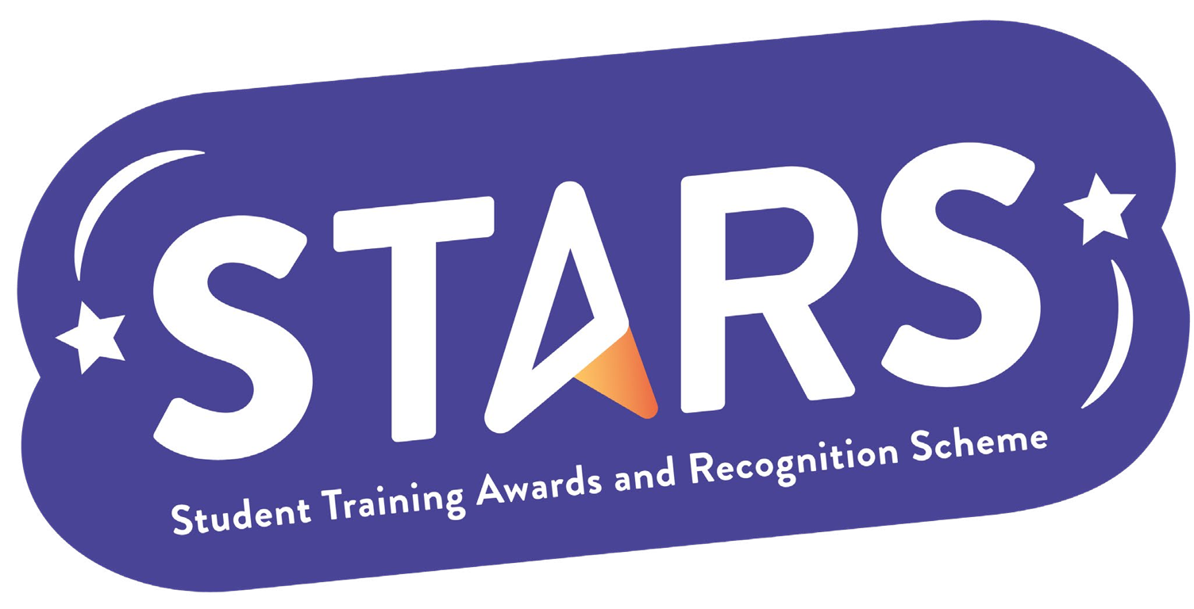

**STARS – Social Media Badge**

**Name of Society:**

**To achieve this badge, you will need to complete at least 3 of the criteria.**

|  |  |  |
| --- | --- | --- |
| **Criteria** | **Description**  (Please describe how your group has met this criteria) | **Evidence**  (Please include photos, screenshots, social media posts, advertisements etc.) |
| Create a 30s promotional video for your Club/Society and share to your social media platform |  |  |
| Have your Club/Society social media account featured on LSESU's Instagram story or post |  |  |
| Maintain an up-to-date page on the LSESU website, and have an active online presence on at least two digital platforms (e.g. WhatsApp and Instagram) |  |  |
| Promote LSESU activities to your platforms (e.g. Instagram, WhatsApp) |  |  |

**MARKERS NOTES:**

|  |  |  |
| --- | --- | --- |
| **Criteria** | **Met? (Y/N)** | **Notes** |
| Create a 30s promotional video for your Club/Society and share to your social media platform |  |  |
| Have your Club/Society social media account featured on LSESU's Instagram story or post |  |  |
| Maintain an up-to-date page on the LSESU website, and have an active online presence on at least two digital platforms (e.g. WhatsApp and Instagram) |  |  |
| Promote LSESU activities to your platforms (e.g. Instagram, WhatsApp) |  |  |