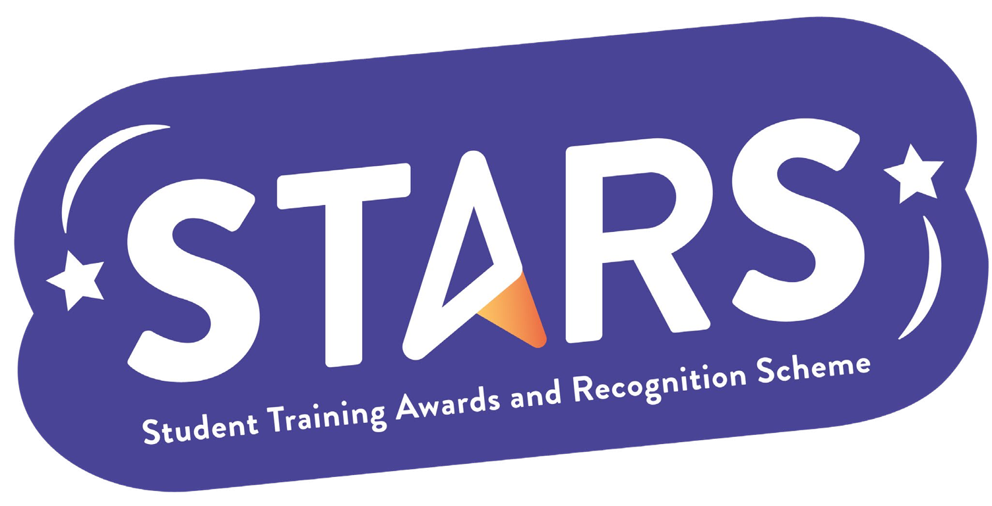

**STARS – Inclusion Badge**

**Name of Society:**

**To achieve this badge, you will need to complete at least 2 of the criteria.**

|  |  |  |
| --- | --- | --- |
| **Criteria** | **Description**  (Please describe how your group has met this criteria) | **Evidence**  (Please include photos, screenshots, social media posts, advertisements etc.) |
| Introduce a buddy or peer-mentoring scheme in your group - with a focus or inclusion and community building (rather than professional development). |  |  |
| Host a free event aimed at demographics underrepresented in your society (e.g. Postgrad students) |  |  |
| Host a Give It A Go event at the start of September Welcome or January Welcome Back (or within a month of your group being set up, if you are a new Club/Society). |  |  |
| Host regular social events (at least once a month during term time) to build a community within your Club/Society. |  |  |

**MARKERS NOTES:**

|  |  |  |
| --- | --- | --- |
| **Criteria** | **Met? (Y/N)** | **Notes** |
| Introduce a buddy or peer-mentoring scheme in your group - with a focus or inclusion and community building (rather than professional development). |  |  |
| Host a free event aimed at demographics underrepresented in your society (e.g. Postgrad students) |  |  |
| Host a Give It A Go event at the start of September Welcome or January Welcome Back (or within a month of your group being set up, if you are a new Club/Society). |  |  |
| Host regular social events (at least once a month during term time) to build a community within your Club/Society. |  |  |