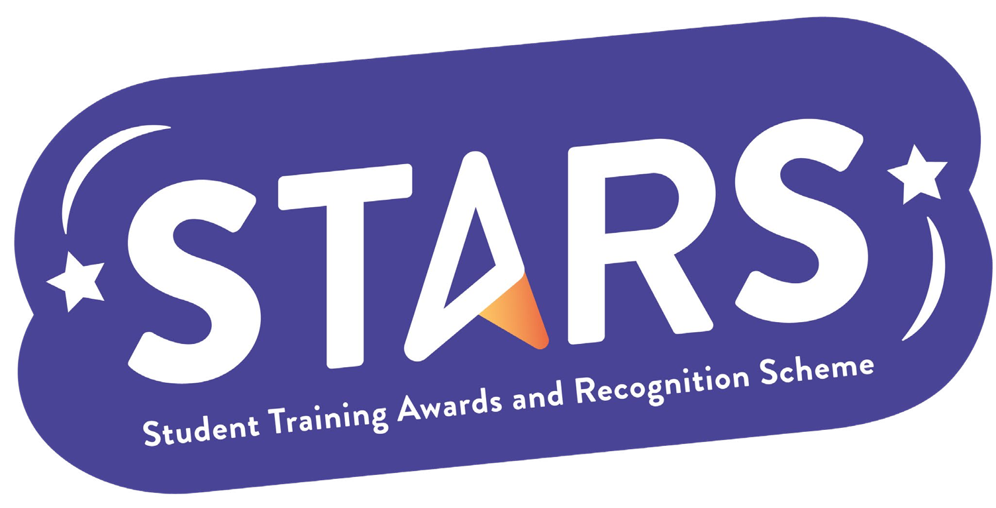

**STARS – Community Badge**

**Name of Society:**

**To achieve this badge, you will need to complete at least 2 of the criteria.**

|  |  |  |
| --- | --- | --- |
| **Criteria** | **Description**  (Please describe how your group has met this criteria) | **Evidence**  (Please include photos, screenshots, social media posts, advertisements etc.) |
| Connect current members with alumni in 2 different ways (e.g. invite alumni to speak at a Club/Society event, have an associate membership and host networking opportunities for current members and alumni). |  |  |
| Host regular social events (at least once a month during term time) to build a community within your Club/Society. |  |  |
| Increase membership by 10% compared to the previous academic year. |  |  |

**MARKERS NOTES:**

|  |  |  |
| --- | --- | --- |
| **Criteria** | **Met? (Y/N)** | **Notes** |
| Connect current members with alumni in 2 different ways (e.g. invite alumni to speak at a Club/Society event, have an associate membership and host networking opportunities for current members and alumni). |  |  |
| Host regular social events (at least once a month during term time) to build a community within your Club/Society. |  |  |
| Increase membership by 10% compared to the previous academic year. |  |  |