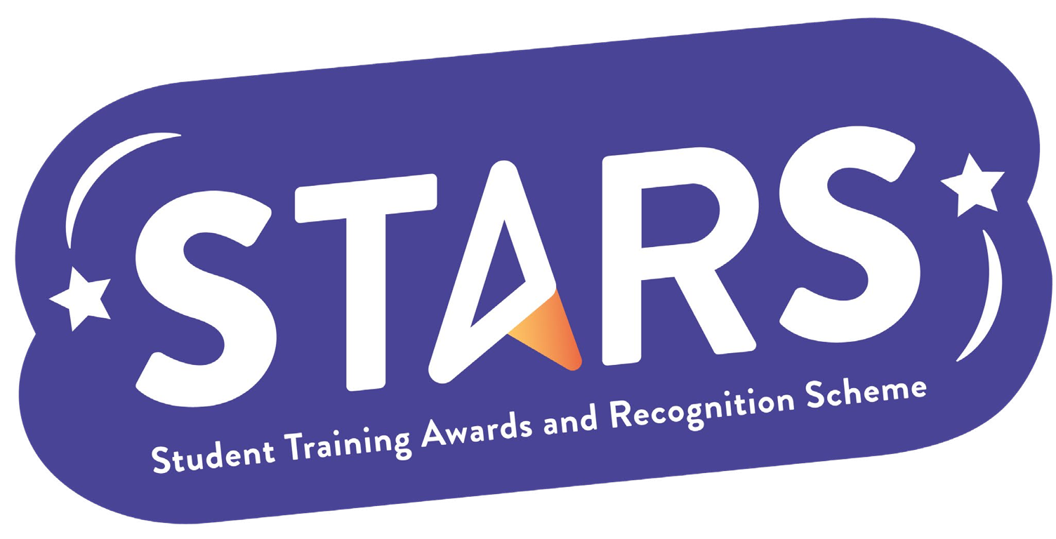

**STARS – Collaboration Badge**

**Name of Society:**

**To achieve this badge, you will need to complete at least 2 of the criteria.**

|  |  |  |
| --- | --- | --- |
| **Criteria** | **Description**  (Please describe how your group has met this criteria) | **Evidence**  (Please include photos, screenshots, social media posts, advertisements etc.) |
| Collaborate on an event with another Club/Society that is unrelated to your own. |  |  |
| Collaborate with a department or external organisation to host an event/initiative that benefits your members (e.g. a speaker event, networking activity). |  |  |
| Receive a sponsorship from a department or external organisation |  |  |

**MARKERS NOTES:**

|  |  |  |
| --- | --- | --- |
| **Criteria** | **Met? (Y/N)** | **Notes** |
| Collaborate on an event with another Club/Society that is unrelated to your own. |  |  |
| Collaborate with a department or external organisation to host an event/initiative that benefits your members (e.g. a speaker event, networking activity). |  |  |
| Receive a sponsorship from a department or external organisation |  |  |